|  |
| --- |
| Batch: ETRX D2 , Roll No.:16010221038  Name: Eshan Kalp Trivedi  Experiment / assignment / tutorial No. 6 Grade: AA / AB / BB / BC / CC / CD /DD    Signature of the Staff In-charge with date |

**Hall Effect**

Aim:

1. To determine the Hall voltage developed across the sample material.
2. To calculate the Hall coefficient and the carrier concentration of the sample material.

Apparatus:

Two solenoids, Constant current supply, Four probe, Digital gauss meter, Hall effect apparatus (which consist of Constant Current Generator (CCG), digital milli voltmeter and Hall probe).

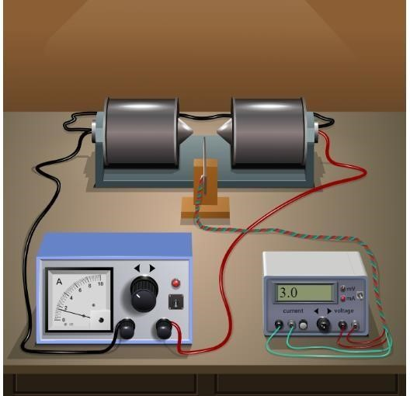

**Observation Table:**

Material: Germanium

Magnetic field B = 0.447 gauss = 0.477 X 10^-4 tesla

|  |  |  |  |
| --- | --- | --- | --- |
| Thickness t = 0.4 mm | | Thickness t = 0.8 mm | |
| IH mA | VH mV | IH mA | VH mV |
| 1 | 21.56 | 1 | 10.78 |
| 1.5 | 32.35 | 1.5 | 16.17 |
| 2 | 43.13 | 2 | 21.57 |
| 2.5 | 53.92 | 2.5 | 26.96 |
| 3 | 64.70 | 3 | 32.35 |
| 3.5 | 75.48 | 3.5 | 37.74 |
| 4 | 86.27 | 4 | 43.13 |
| 4.5 | 97.05 | 4.5 | 48.52 |
| 5 | 107.83 | 5 | 53.92 |

**Graph:**

Plot Hall voltage (Y-axis) v/s Hall current (X-axis) for different thicknesses

B

**Formula:** carrier concentration n =

q × t × slope

|  |  |
| --- | --- |
|  |  |
| n (1)= | 0.477 x 10 ^(-4)    1.6 x 10^(-19)x 0.4x10^(-3)x21.57 |
| = | 3.45 x 10^(16) |
| n(2)= | 0.477 x 10 ^(-4)    1.6 x 10^(-19)x 0.8x10^(-3)x43.14 |
| = | 8.63 x 10 ^(15) |

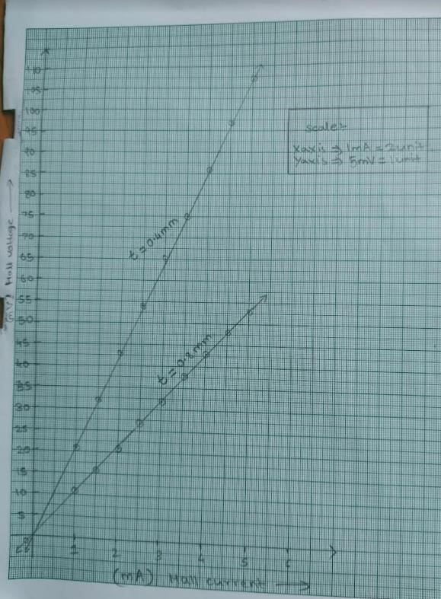

**Home Assignment:**

Keep Hall current (IH) fixed at 3 mA. Vary Magnet current in steps of 0.5 A and note Hall

voltage. Plot graph of Hall voltage (Y-axis) v/s Magnetic field* for any one thickness. Calculate

IH carrier concentration using the formula: n =

q × t × slope

*Find magnetic field for different magnet currents by selecting “Magnetic field v/s Current” from the “Select Procedure” drop-down menu of the simulator.

Observation table for Home Assignment:

Material: Germanium

Hall current: 3 mA

|  |  |  |
| --- | --- | --- |
| Thickness t = 0.4 mm | |  |
| I ampere (magnet current) | B gauss | VH mV |
| 1 | 0.1482 | 21.567 |
| 1.5 | 0.2223 | 32.350 |
| 2 | 0.2964 | 43.133 |
| 2.5 | 0.3706 | 53.917 |
| 4 | 0.4447 | 64.700 |
| 3.5 | 0.5188 | 75.484 |
| 4 | 0.5929 | 86.267 |
| 4.5 | 0.6670 | 97.050 |
| 5 | 0.7411 | 107.837 |

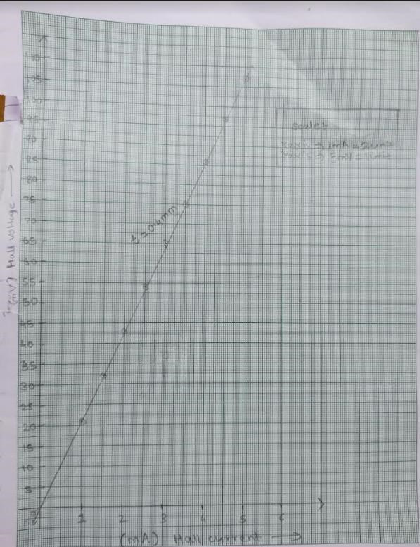

n = 0.3 x 10(-3)

1.6 x 10^(-19)x 0.4x10^(-3)x21.57

= 2.173 x 10^(17)